**MEDIA RELEASE**

**7 April 2021**

**With Formal Accreditation of Dental Continuing Professional Development (CPD) commencing across Australia & New Zealand, it’s time to ask . . . is your Dental CPD Accredited?**

**In line with recent Scope of Practice changes and Recertification requirements for Dental Practitioners across Australia and New Zealand, the Dental Education Accreditation Committee (DEAC) has been tasked with formally accrediting both Providers of Dental CPD and their activities, for the benefit of practitioners; the profession; and the public.**

**The Problem**

CPD is an umbrella term used to describe a plethora of learning activities which Dental Practitioners engage in to develop, enhance and maintain their knowledge and abilities throughout their professional careers.

In recent years, the number of individuals and organisations claiming to provide appropriate CPD and the volume and variety of activities claiming to represent appropriate CPD, have grown exponentially, with education becoming a big business.

While all Dental Practitioners have an annual CPD obligation in order to comply with the requirements for ongoing Registration and Recertification, there have, to date, been very few safeguards in place to ensure that CPD being undertaken is of the requisite standard to achieve the goals of career-long learning.

Additionally, there has been a dramatic rise in complaints against Practitioners over recent years, with the vast majority being related to the standard of clinical care1, requiring disciplinary bodies to prescribe courses of corrective quality education, to ensure standards are met.

**The Solution**

As a result, serious concern exists regarding the creation of a CPD “perfect storm” – Practitioners being compelled to engage in CPD activities but failing to perform their own due diligence; focused solely on fulfilling an arbitrary quota instead of engaging in a conscious and proactive quality assessment; while being misled by commercially focused CPD providers making a variety of claims as to their education credentials, often listing compliance with a variety of paid accreditation services based in the UK, USA or Europe.

To address these concerns, a framework of formal accreditation for both Providers of Dental CPD and their activities has been introduced across Australia and New Zealand, with the Dental Education Accreditation Committee performing these functions.

Paralleling those processes used to accredit Dental Schools and Programs of Study leading to initial Provider Registration, The DEAC formal CPD accreditation functions have been assigned in line with the CPD Standards, Policies, Guidelines and Re-Certification requirements of the Dental Board of Australia and the Dental Council of New Zealand, filling a regulatory void and providing vital assurances as to the quality and integrity of ongoing dental professional development and competencies.

While its primary purpose is to demonstrate to the profession whether or not individual CPD Providers and their Activities have met an appropriate Standard, the DEAC acknowledges that innovation and diversity of CPD Providers and in their chosen teaching and learning approaches, forms a vital component in strengthening  the continuum of dental education across Australian and New Zealand.

The DEAC Accreditation Framework is designed to reflect the expectations of the Profession and Regulators, while not unduly restricting the ways in which CPD Providers achieve these outcomes.

By applying an impartial and objective assessment of the structure, content, legitimacy and value of CPD Providers and their activities, the DEAC is able to work with Providers of CPD to develop, such that may meet the Accreditation Standards, rather than arbitrarily denying Accreditation.

Providing a framework, support and guidance to the Dental Profession in relation to CPD best practice, affords clarity and certainty for:

* Dental Practitioners, on how best to meet their professional obligations for continued Registration and Recertification
* CPD providers, on how best to develop appropriate CPD activities
* The safety and protection of the public, giving the community confidence that Dental Practitioners maintain competency standards throughout their professional careers.

**What to look for**

The DEAC qualitative, two-tier accreditation process results in both CPD Providers and their accredited activities, will bear "DEAC Accredited" symbols. Activity symbols carry a two-character code, where the number relates to the number of accredited CPD hours, and the letter relates to the type of CPD – “N” for Non-Scientific and “S” for Scientific. Note that while a Provider may be accredited, not all of their programs may have achieved accreditation and both symbols should be displayed.

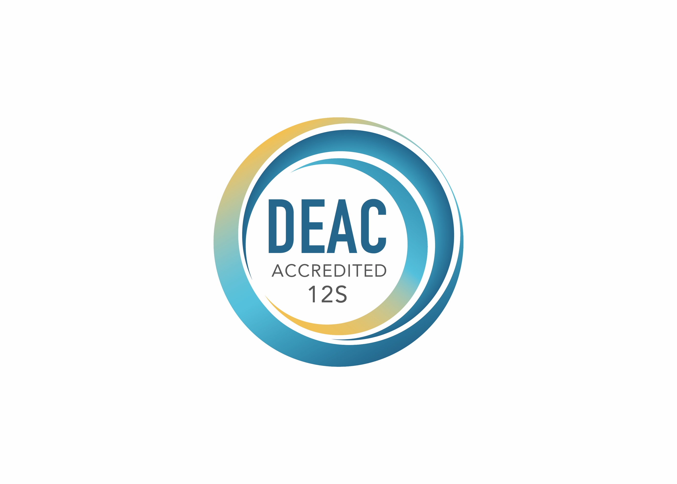

***About the DEAC***

*The independent, non-profit authority assigned responsibility for formally accrediting Providers of Continuing Professional Development (CPD) & their activities in the profession of Dentistry, throughout Australia & New Zealand.*

1. https://www.ahpra.gov.au/Publications/Annual-reports/Annual-Report-2020/Notifications.aspx

**Ends**

**Media Contact:**

Natalie Pritchard

DEAC Communications Director

E: enquiries@dentalcommittee.org

Dental Education Accreditation Committee

GPO Box PERTH WA 6000

dentalcommittee.org